CREATING IBM CLOUD SERVICE

|  |  |
| --- | --- |
| DATE | 26 OCT 2022 |
| TEAM ID | PNT2022TMID44628 |
| PROJECT NAME | IOT BASED SAFETY GADGET FOR CHILD SAFETY MONITORING AND NOTIFICATION |

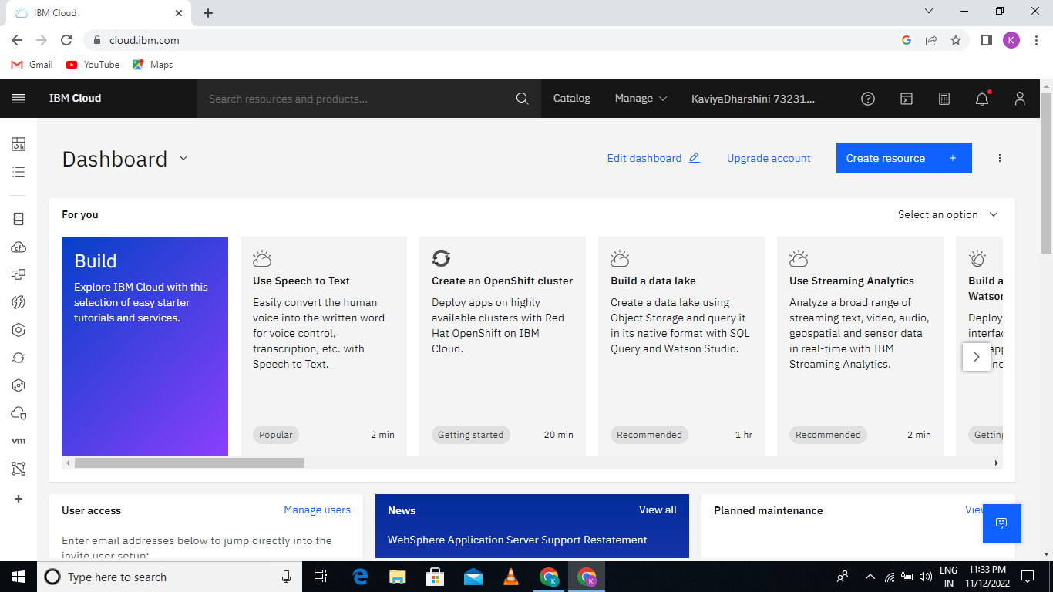

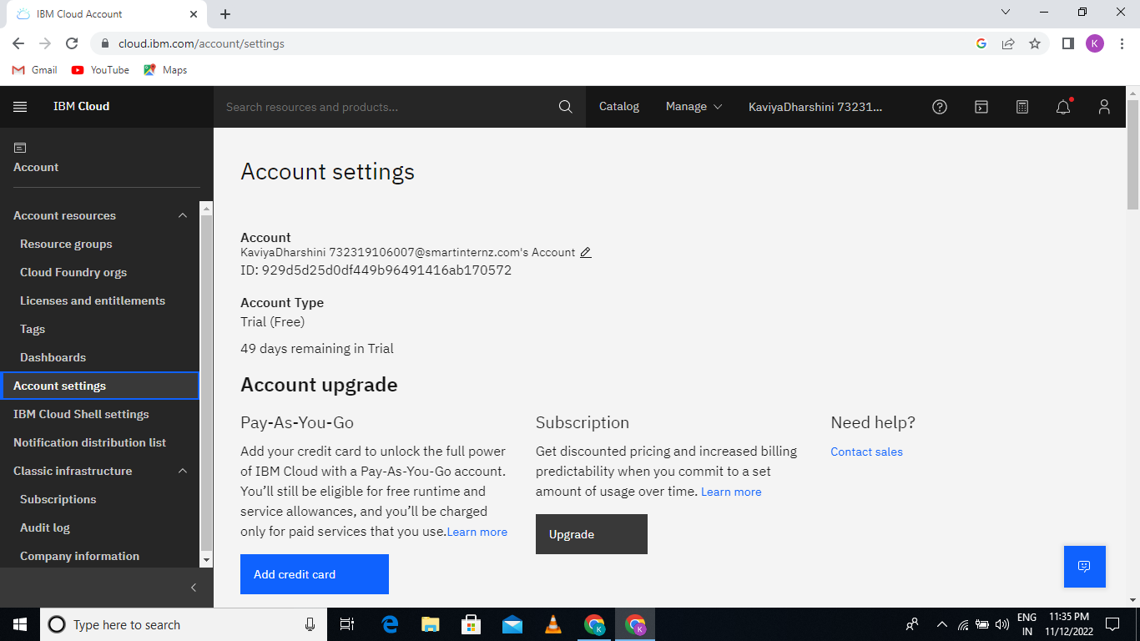

AN IBM CLOUD SERVICE CREATE SUCCESSFULLY